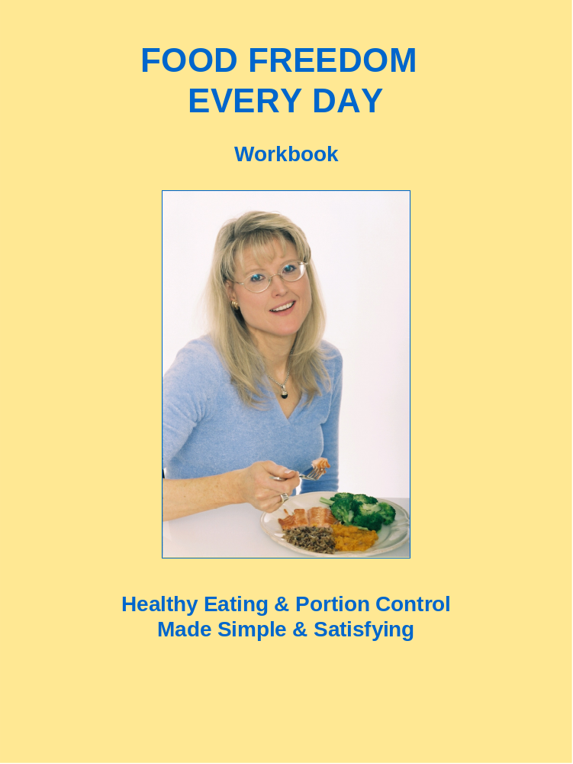

Welcome to Food Freedom!
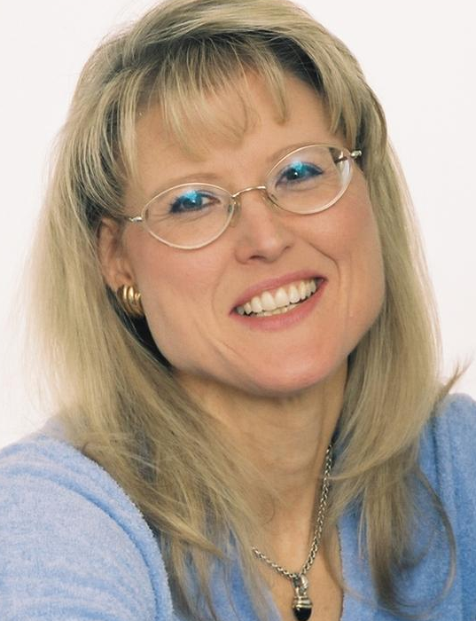

I’m Alice Greene, your Food Freedom success coach.

I am delighted to be your guide as you embark on your new journey with food and self-discovery.

This program is very different from doing a diet. Instead it will change your relationship with food and give you self-awareness, self-confidence and self-control. More importantly it will teach you how to make healthy and satisfying food choices that feels easy, intuitive and freeing. You CAN succeed at healthy eating, having foods you love without guilt and being able to stop yourself from overeating or bingeing. I am going to show you how in the weeks ahead, and this workbook is going to support you along the way.
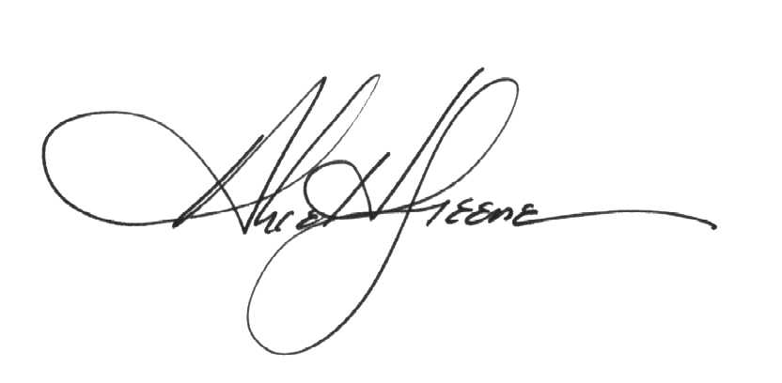

QUESTIONNAIRE

Name __________________________________

Workshop Goals
Why are you participating in this workshop?
__________________________________________________________________________________________________________________________________________________________

What about your eating habits do you hope to change or improve?
__________________________________________________________________________________________________________________________________________________________

What eating issue, if any, do you hope to finally resolve so you can eat normally?
__________________________________________________________________________________________________________________________________________________________

Why is this really important to you?
__________________________________________________________________________________________________________________________________________________________

What will you be able to do once you attain these goals?
__________________________________________________________________________________________________________________________________________________________

Your Current Relationship with Food
What is your greatest challenge with food and eating?
__________________________________________________________________________________________________________________________________________________________
__________________________________________________________________________________________________________________________________________________________

Have you been on any diets? _______
If so, how many diets do you think you’ve been on? ______
If so, when and what was the last diet? when___________ what___________________

What do you think makes it difficult for you to eat healthy foods on a regular basis?
__________________________________________________________________________________________________________________________________________________________
__________________________________________________________________________________________________________________________________________________________

When was the last time you were eating in a healthier way? And why did you stop?
__________________________________________________________________________________________________________________________________________________________
__________________________________________________________________________________________________________________________________________________________

What do you consider to be your weakness with food?
__________________________________________________________________________________________________________________________________________________________
__________________________________________________________________________________________________________________________________________________________

Is overeating or bingeing an issue for you? If so, how often does this seem to happen and when?
__________________________________________________________________________________________________________________________________________________________
__________________________________________________________________________________________________________________________________________________________

Do you suspect you are an emotional eater? If so, why do you think that?
__________________________________________________________________________________________________________________________________________________________
__________________________________________________________________________________________________________________________________________________________

What else do you think would be helpful for me to know?
__________________________________________________________________________________________________________________________________________________________
__________________________________________________________________________________________________________________________________________________________

Fax this back to me at 978-462-1349 or
Email a copy of these pages to me at agreene@feelyourpersonalbest.com.

CLASS NOTES – WEEK 1: Self Awareness & Portion Control

__________________________________________________________________________________________________________________________________________________________
__________________________________________________________________________________________________________________________________________________________
__________________________________________________________________________________________________________________________________________________________
__________________________________________________________________________________________________________________________________________________________
__________________________________________________________________________________________________________________________________________________________
__________________________________________________________________________________________________________________________________________________________
__________________________________________________________________________________________________________________________________________________________
__________________________________________________________________________________________________________________________________________________________
__________________________________________________________________________________________________________________________________________________________
__________________________________________________________________________________________________________________________________________________________
__________________________________________________________________________________________________________________________________________________________
__________________________________________________________________________________________________________________________________________________________
__________________________________________________________________________________________________________________________________________________________
__________________________________________________________________________________________________________________________________________________________
__________________________________________________________________________________________________________________________________________________________
__________________________________________________________________________________________________________________________________________________________
__________________________________________________________________________________________________________________________________________________________
__________________________________________________________________________________________________________________________________________________________

__________________________________________________________________________________________________________________________________________________________
__________________________________________________________________________________________________________________________________________________________
__________________________________________________________________________________________________________________________________________________________
__________________________________________________________________________________________________________________________________________________________
__________________________________________________________________________________________________________________________________________________________
__________________________________________________________________________________________________________________________________________________________
__________________________________________________________________________________________________________________________________________________________
__________________________________________________________________________________________________________________________________________________________
__________________________________________________________________________________________________________________________________________________________
__________________________________________________________________________________________________________________________________________________________
__________________________________________________________________________________________________________________________________________________________
__________________________________________________________________________________________________________________________________________________________
__________________________________________________________________________________________________________________________________________________________
__________________________________________________________________________________________________________________________________________________________
__________________________________________________________________________________________________________________________________________________________
__________________________________________________________________________________________________________________________________________________________
__________________________________________________________________________________________________________________________________________________________
__________________________________________________________________________________________________________________________________________________________
_____________________________________________________________________________
_____________________________________________________________________________

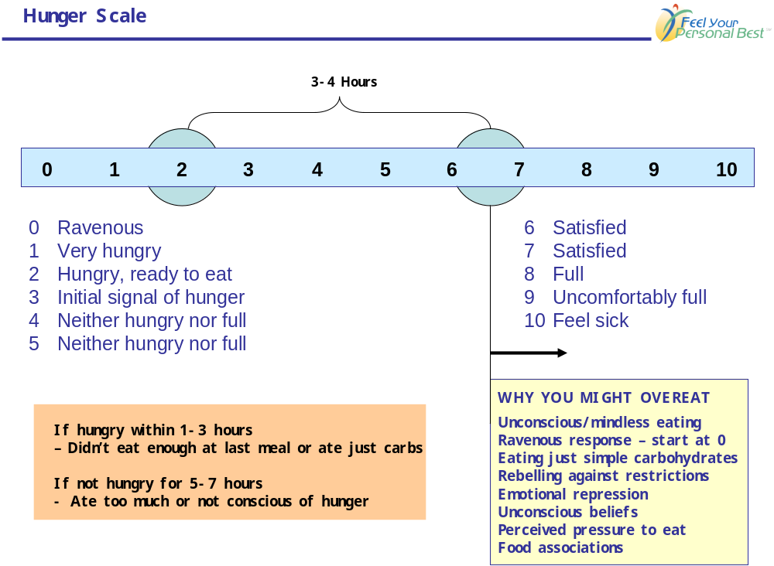

_____________________________________________________________________________
__________________________________________________________________________________________________________________________________________________________
__________________________________________________________________________________________________________________________________________________________
__________________________________________________________________________________________________________________________________________________________
__________________________________________________________________________________________________________________________________________________________
__________________________________________________________________________________________________________________________________________________________
__________________________________________________________________________________________________________________________________________________________
__________________________________________________________________________________________________________________________________________________________

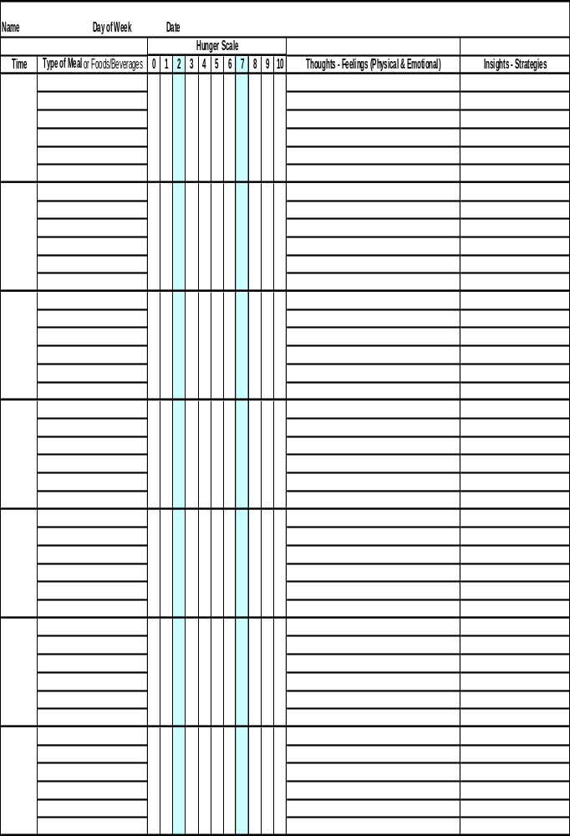

__________________________________________________________________________________________________________________________________________________________
__________________________________________________________________________________________________________________________________________________________
__________________________________________________________________________________________________________________________________________________________
__________________________________________________________________________________________________________________________________________________________
__________________________________________________________________________________________________________________________________________________________
__________________________________________________________________________________________________________________________________________________________
__________________________________________________________________________________________________________________________________________________________
__________________________________________________________________________________________________________________________________________________________
__________________________________________________________________________________________________________________________________________________________
__________________________________________________________________________________________________________________________________________________________
__________________________________________________________________________________________________________________________________________________________
__________________________________________________________________________________________________________________________________________________________
__________________________________________________________________________________________________________________________________________________________
__________________________________________________________________________________________________________________________________________________________
__________________________________________________________________________________________________________________________________________________________
__________________________________________________________________________________________________________________________________________________________
__________________________________________________________________________________________________________________________________________________________
__________________________________________________________________________________________________________________________________________________________
_____________________________________________________________________________
_____________________________________________________________________________
JOURNAL PAGES
Write about your Observations, Patterns, Insights, Etc.
__________________________________________________________________________________________________________________________________________________________
__________________________________________________________________________________________________________________________________________________________
__________________________________________________________________________________________________________________________________________________________
__________________________________________________________________________________________________________________________________________________________
__________________________________________________________________________________________________________________________________________________________
__________________________________________________________________________________________________________________________________________________________
__________________________________________________________________________________________________________________________________________________________
__________________________________________________________________________________________________________________________________________________________
__________________________________________________________________________________________________________________________________________________________
__________________________________________________________________________________________________________________________________________________________
__________________________________________________________________________________________________________________________________________________________
__________________________________________________________________________________________________________________________________________________________
__________________________________________________________________________________________________________________________________________________________
__________________________________________________________________________________________________________________________________________________________
__________________________________________________________________________________________________________________________________________________________
__________________________________________________________________________________________________________________________________________________________
__________________________________________________________________________________________________________________________________________________________
__________________________________________________________________________________________________________________________________________________________

__________________________________________________________________________________________________________________________________________________________
__________________________________________________________________________________________________________________________________________________________
__________________________________________________________________________________________________________________________________________________________
__________________________________________________________________________________________________________________________________________________________
__________________________________________________________________________________________________________________________________________________________
__________________________________________________________________________________________________________________________________________________________
__________________________________________________________________________________________________________________________________________________________
__________________________________________________________________________________________________________________________________________________________
__________________________________________________________________________________________________________________________________________________________
__________________________________________________________________________________________________________________________________________________________
__________________________________________________________________________________________________________________________________________________________
__________________________________________________________________________________________________________________________________________________________
__________________________________________________________________________________________________________________________________________________________
__________________________________________________________________________________________________________________________________________________________
__________________________________________________________________________________________________________________________________________________________
__________________________________________________________________________________________________________________________________________________________
__________________________________________________________________________________________________________________________________________________________
__________________________________________________________________________________________________________________________________________________________
______________________________________________________________________________________
______________________________________________________________________________________

COACHING SESSION NOTES

__________________________________________________________________________________________________________________________________________________________
__________________________________________________________________________________________________________________________________________________________
__________________________________________________________________________________________________________________________________________________________
__________________________________________________________________________________________________________________________________________________________
__________________________________________________________________________________________________________________________________________________________
__________________________________________________________________________________________________________________________________________________________
__________________________________________________________________________________________________________________________________________________________
__________________________________________________________________________________________________________________________________________________________
__________________________________________________________________________________________________________________________________________________________
__________________________________________________________________________________________________________________________________________________________
__________________________________________________________________________________________________________________________________________________________
__________________________________________________________________________________________________________________________________________________________
__________________________________________________________________________________________________________________________________________________________
__________________________________________________________________________________________________________________________________________________________
__________________________________________________________________________________________________________________________________________________________
__________________________________________________________________________________________________________________________________________________________
__________________________________________________________________________________________________________________________________________________________
__________________________________________________________________________________________________________________________________________________________

__________________________________________________________________________________________________________________________________________________________
__________________________________________________________________________________________________________________________________________________________
__________________________________________________________________________________________________________________________________________________________
__________________________________________________________________________________________________________________________________________________________
__________________________________________________________________________________________________________________________________________________________
__________________________________________________________________________________________________________________________________________________________
__________________________________________________________________________________________________________________________________________________________
__________________________________________________________________________________________________________________________________________________________
__________________________________________________________________________________________________________________________________________________________
__________________________________________________________________________________________________________________________________________________________
__________________________________________________________________________________________________________________________________________________________
__________________________________________________________________________________________________________________________________________________________
__________________________________________________________________________________________________________________________________________________________
__________________________________________________________________________________________________________________________________________________________
__________________________________________________________________________________________________________________________________________________________
__________________________________________________________________________________________________________________________________________________________
__________________________________________________________________________________________________________________________________________________________
__________________________________________________________________________________________________________________________________________________________
_____________________________________________________________________________
_____________________________________________________________________________
GROUP MEMBERS

Name ____________
__________________________________________________________________________________________________________________________________________________________
_____________________________________________________________________________

Name ____________
__________________________________________________________________________________________________________________________________________________________
_____________________________________________________________________________

Name ____________
__________________________________________________________________________________________________________________________________________________________
_____________________________________________________________________________

Name ____________
__________________________________________________________________________________________________________________________________________________________
_____________________________________________________________________________

Name ____________
__________________________________________________________________________________________________________________________________________________________
_____________________________________________________________________________

Name ____________
__________________________________________________________________________________________________________________________________________________________
_____________________________________________________________________________

Name ____________
__________________________________________________________________________________________________________________________________________________________
_____________________________________________________________________________

Name ____________
__________________________________________________________________________________________________________________________________________________________

